Please import project in eclipse or any other IDE and provide arguments as file name, or if running from command prompt than give file name as command line argument.

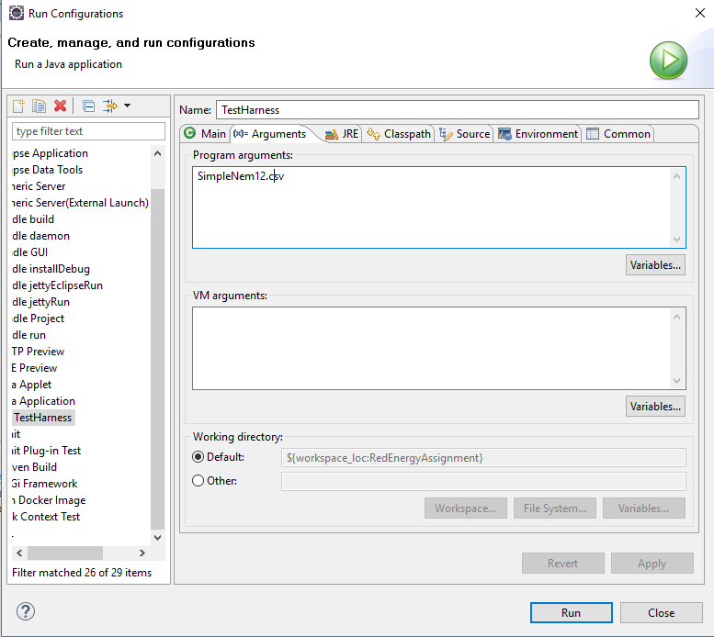

Sample console output

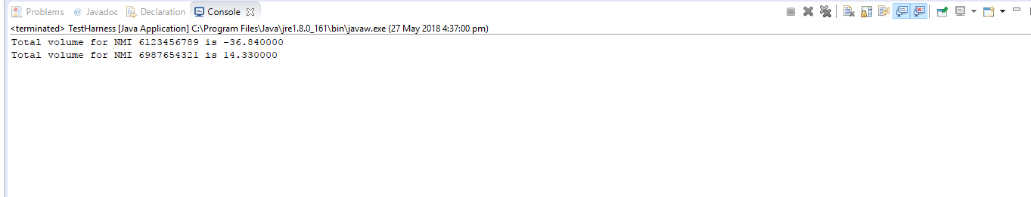

Note :

Seperate Validator and Custom Exception Handler Could have been created and more unit test can be added. Overall goal was to simply outputting data as expected with basic validations.